User Manual

Sweet 16 Measurement Software

Felix Rucker

2018

Inhaltsverzeichnis

Supported Instruments 2

Sweet 16 2

Gustav 2

Starting The System 3

Running The System Monitor 4

System Monitor Handling 4

Data Logging 4

Delete Data LoG or Reduce Data Density 4

Choose Monitor aPPEArance 5

Plot Control 5

SAVE and REstore Monitor Settings 5

Reduce Data Density 5

Set Data acquisition Time 5

Reset Warnings 5

Start a Measurement Skript 5

Stop The System Monitor 5

Utilities 6

Instrument Setup 6

Configuration File 6

Command File 6

System Monitor 6

# Supported Instruments

## Sweet 16

**Measurement software root directory:** D:\Software\CryoTUM

**Currently Supported Measurement Options**:

1. Field Sweeps
2. Temperature Sweeps (16T VTI)
3. Angle Sweeps (16T VTI)

**Currently Supported Instrument Controller:**

1. IPS Magnet Controller (16 T Monitor)
2. ILM Level Meter (ILM Monitor)
3. ITC 503 Temperature Controller (16TVTI Monitor)
4. ITC 503 Lambda Controller (Lambda Monitor)

**Currently Available Measurement Equipment**

1. Stanford Research SR 830 Lock-In Amplifier
2. Torque Monitor Control
3. Lake Shore 350 Temperature Controller
4. Lake Shore 370 Temperature Controller (GPIB only)
5. Lake Shore 372 Temperature Controller (GPIB only)

## Gustav

**Measurement software root directory:**  D:\Software\CryoTUM

**Currrently Supported Measurement Options**:

**Currently Supported Instrument Controller:**

1. Mercury ITC Temperature Controller
2. Mercury IPS Magnet Control

**Currently Available Measurement Equipment**

1. Stanford Research SR 830 Lock-In Amplifier
2. Lake Shore 370 Temperature Controller (GPIB only)
3. Lake Shore 372 Temperature Controller (GPIB only)

# Starting The System

To start CroyTUM software, execute the Start_Experiment.vi which can be found in the root directory of the software (or link on the Desktop). The corresponding root directory for the corresponding system can be found in section Supported Instruments. The Vi will execute the following utilities:

1. Run open_config.vi
2. Execute S16EPMS.vi

The user will be asked for a valid instrument setup configuration file (cf. Configuration File). Choose a valid file and confirm. If you do not have a valid configuration file for your experiment, refer to section Configuration File for a guide to preparing your own configuration file.

Subsequently the System Monitor (S16EPMS) is started using the given configuration file.

Carefull The System Monitor automatically starts all corresponding Instrument and Equipment monitors. Make sure that you only enabled valid instruments in the Instrument Setup.

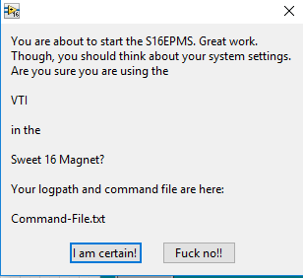Following that, the user will be prompted the following summary of important instrument parameters, which have been set in the Instrument Setup.

Make sure that you have chosen the correct insert in the correct magnet environment. Remember the path (with respect to your root directory) of your command-file, which will be used to execute automated measurements   
(cf Command File).

If you are sure that you have chosen the correct parameters, confirm by pressing the I am certain button, which will start the System Monitor.

You will be asked if you want to restore the data from the previous run. By choosing yes you will load the previously collected data history. By choosing no, the system monitor starts a new data log. This concerns only the internal memory of the System Monitor. Data Logfiles which are stored in the Logfile directory (cf Data Logging) are never deleted.

# Running The System Monitor

Once you have started the system monitor, it will reset itself to a default configuration, then starts the corresponding Instrument and Equipment monitors and starts collecting data, according to your instrument setup.

## System Monitor Handling

### Choose Monitor aPPEArance

The system monitor has the following default appearance (see figure). The upper part (black frame) is defined by the instrument setup (magnet cluster and temperature control cluster, in this example orange and yellow). Everything else within the black box is static and cannot be changed.

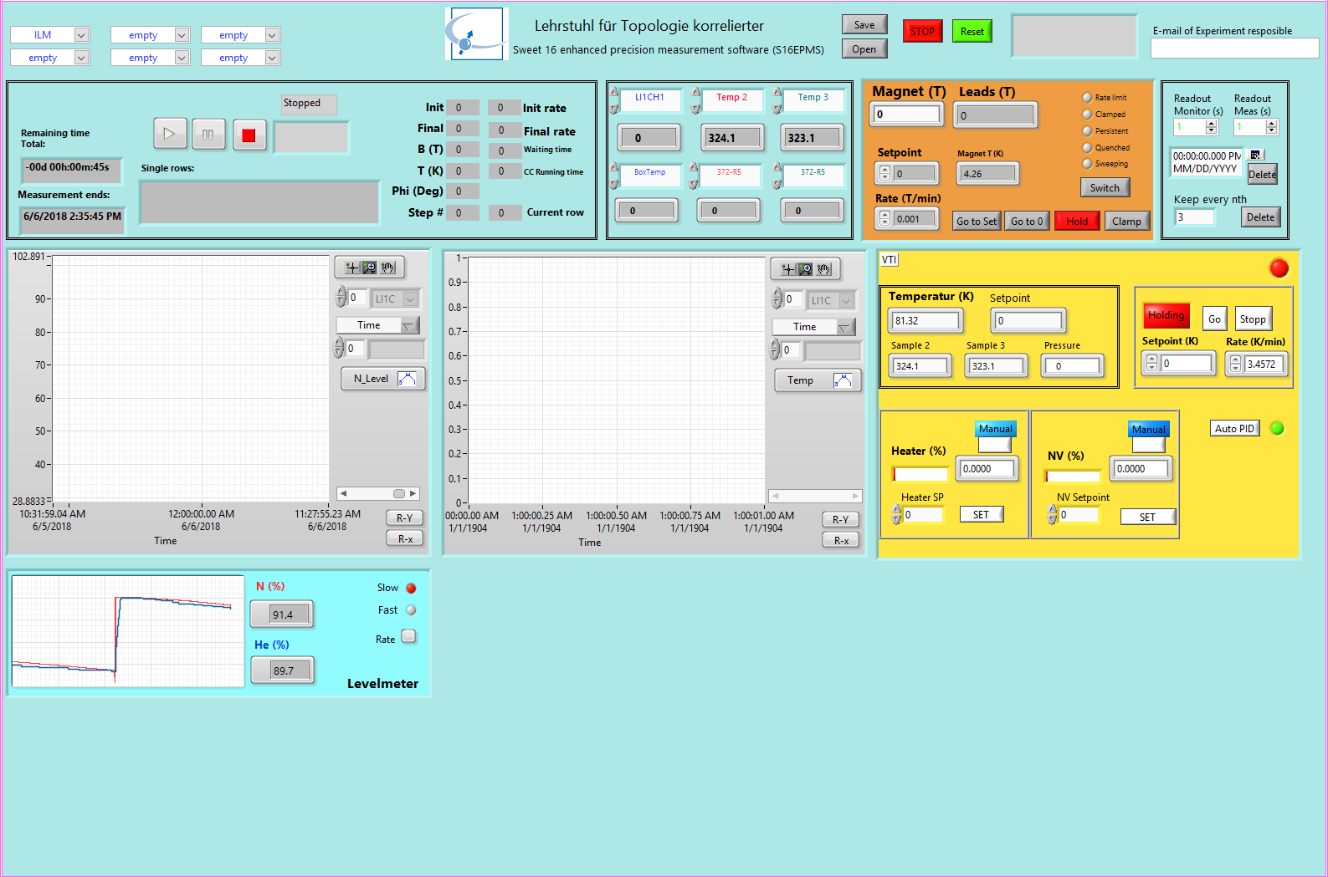

The lower part, however, can be adapted to fit the demands of the specific experiments.

### Plot Control

### SAVE and REstore Monitor Settings

### Reduce Data Density

### Set Data acquisition Time

The lower part of the Monitor, however, can be adapted to fit the demands of the specific experiments. By choosing specific monitor clusters in the upper left corner (orange frame), additional Data monitors can be added to the bottom of the Monitor. A total number of 6 additional clusters can be added. Moreover, additional plot windows can be added, however, occupying two cluster slots. All monitor clusters are unique and can only be added once. A second addition will have no influence on the Monitor appearance. By default, the Levelmeter cluster is activated on position (1,1).

### Data Logging

All data is logged into a logfile. The Logfile directory is /../Logfiles/ with respect to your root directory. Each day, a new logfile is created with the syntax: yyyymmdd.txt.

The System Monitor always logs into one, day specific, logfile. Multiple logfiles for one day are not possible. Logfiles are never deleted by the system monitor.

The data readout time of the system monitor (this is not the density in the measurement file, cf Start a Measurement Skript) can be chosen in the Readout Monitor field. Default is one second. At this density, however, the data log has to be reduced every few days to prevent the System Monitor from slowing down too much.

The readout time of the system monitor is constantly monitored. In case the system can’t reach the desired readout time, the number will turn from green to red. In this case, either the readout time has to be increase, or the data size has to be reduced.

### Delete Data LoG or Reduce Data Density

The system Monitors internal data log can be deleted (not the Lofiles stored in the Logfile folder). This might be necessary when a measurement has been running constantly over various days at a high read-out frequency. In this case, the high number of data points in the internal memory reduces the Monitor speed considerably.

To delete data from the internal log, choose a date and a time by pressing the calendar button in the measurement timing cluster (see figure). Upon pressing the corresponding delete button, all data taken before the chosen date is deleted from the internal memory.

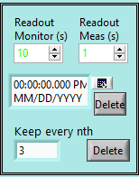

Calendar

Alternatively, the data size can be reduced by reducing the data density. Therefore, choose how many data points to keep (keep every nth) and hit the corresponding delete button to reduce the data density.

### WarninG Handling & Email-Service

In case of an error in the system monitor itself, as well as in one of the Instrument or Equipment Monitors, an error message is displayed in the string indicator field in the upper right corner (grey shaded).

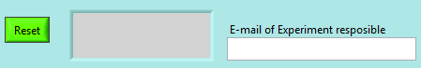

Possible errors are all internal Labview errors, which might occur e.g. when the communication between monitor and instrument is faulty. Additionally, several system specific critical errors can be raised by the system monitor. These include so-far:

* Critical helium level
* Critical Magnet Temperature in Lambda mode
* Critical Dewar pressure (Gustav)
* Critical Dewar Heater output (Gustav)
* Critical pressures in the JT-Control System

In case of a critical error, the system monitor sends an email to the administrator (currently: [felix.rucker@frm2.tum.de](mailto:felix.rucker@frm2.tum.de)) as well as to all e-mail addresses, given in the Experiment responsible field. Here, coma separated e-mail addresses can be added to the e-mail service.

All warnings can be reset by pressing the reset button. Note that if the error still exists, the system will automatically prompt the warning message again, and, in case of a critical error, re-send an e-mail.

# Start a Measurement Skript

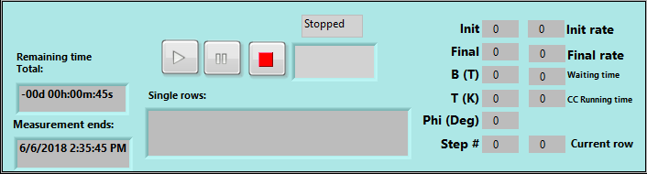This section describes how to run a measurement script. Please refer to section Command File to learn how to prepare a script. The measurement control of the System Monitor can be found in the upper left corner.

The measurement control includes a play, a pause and a stop button. These can be used to control automated measurements which are run by the main.vi. Hereby play, pause and stop directly translate into the common LabView VI-control button. If a measurement is running or paused, this will be indicated in the string indicator located above the buttons (1).

# Stop The System Monitor

# Utilities

## Instrument Setup

### Configuration File

## Command File

# System Monitor